**PRAKTIKUM 7**

**Neural Network using R menggunakan data weather numerik**

> data7=read.delim("clipboard")

> ind <- sample(2, nrow(data7), replace = TRUE, prob=c(0.7, 0.3))

> ind

[1] 1 2 2 1 1 1 1 1 1 2 1 1 1 2

> trainset = data7[ind == 1,]

> testset = data7[ind == 2,]

> trainset$Play = trainset$Class == "Play"

> trainset$DontPlay = trainset$Class == "DontPlay"

> network_prak7 = neuralnet(Play + DontPlay~Temp + Humidity, trainset, hidden=3)

> network_prak7

$call

neuralnet(formula = Play + DontPlay ~ Temp + Humidity, data = trainset,

hidden = 3)

$response

Play DontPlay

1 TRUE FALSE

4 TRUE FALSE

5 TRUE FALSE

6 TRUE FALSE

7 TRUE FALSE

8 FALSE TRUE

9 TRUE FALSE

11 TRUE FALSE

12 FALSE TRUE

13 FALSE TRUE

$covariate

[,1] [,2]

[1,] 64 65

[2,] 75 70

[3,] 81 75

[4,] 83 78

[5,] 68 80

[6,] 71 80

[7,] 75 80

[8,] 72 90

[9,] 80 90

[10,] 72 95

$model.list

$model.list$response

[1] "Play" "DontPlay"

$model.list$variables

[1] "Temp" "Humidity"

$err.fct

function (x, y)

{

1/2 * (y - x)^2

}

<bytecode: 0x00000000168a8130>

<environment: 0x0000000005994938>

attr(,"type")

[1] "sse"

$act.fct

function (x)

{

1/(1 + exp(-x))

}

<bytecode: 0x0000000003266710>

<environment: 0x0000000005994938>

attr(,"type")

[1] "logistic"

$linear.output

[1] TRUE

$data

Temp Humidity Class Play DontPlay

1 64 65 Play TRUE FALSE

4 75 70 Play TRUE FALSE

5 81 75 Play TRUE FALSE

6 83 78 Play TRUE FALSE

7 68 80 Play TRUE FALSE

8 71 80 DontPlay FALSE TRUE

9 75 80 Play TRUE FALSE

11 72 90 Play TRUE FALSE

12 80 90 DontPlay FALSE TRUE

13 72 95 DontPlay FALSE TRUE

$net.result

$net.result[[1]]

[,1] [,2]

1 1.0095065734 -0.009525368750

4 1.0095618909 -0.009580691461

5 1.0095618920 -0.009580692506

6 1.0095618910 -0.009580691528

7 0.4004851475 0.599553536490

8 0.4053927391 0.594645481717

9 0.9541150545 0.045871378071

11 0.4004611124 0.599577573829

12 0.4013607596 0.598677841757

13 0.4004611118 0.599577574431

$weights

$weights[[1]]

$weights[[1]][[1]]

[,1] [,2] [,3]

[1,] 0.4654078806 10.633719056 1.8459489418

[2,] -0.1934184361 1.777325090 2.1434141231

[3,] 0.9653641754 -1.770399821 -0.6495965546

$weights[[1]][[2]]

[,1] [,2]

[1,] 0.7672519399 -0.1777438248

[2,] -0.2341563553 0.5083731589

[3,] 0.6091007804 -0.6091582671

[4,] -0.1326344727 0.2689482403

$startweights

$startweights[[1]]

$startweights[[1]][[1]]

[,1] [,2] [,3]

[1,] 0.4654078806 0.8676121064 1.8459489418

[2,] -0.1934184361 -1.0754563986 2.1434141231

[3,] 0.9653641754 -2.3961123529 -0.6495965546

$startweights[[1]][[2]]

[,1] [,2]

[1,] 1.6275373724 -0.003856743929

[2,] 0.6261290773 0.682260239734

[3,] -0.2302233363 0.266750327504

[4,] 0.7276509599 0.442835321211

$generalized.weights

$generalized.weights[[1]]

[,1] [,2] [,3]

1 -0.0102439285811999677284 0.0102040135619167540715 0.0102244899759950068352

4 -0.0000002299688041689113 0.0000002290727407904741 0.0000002295349156801166

5 -0.0000000375619711647059 0.0000000374156125883579 0.0000000374911019648411

6 -0.0000002175745508027775 0.0000002167267810900164 0.0000002171640468966801

7 0.0001779179025073205158 -0.0001772246531886517631 -0.0001779404015400868461

8 0.0360678566541406814272 -0.0359273198295774684463 -0.0360723431861012105992

9 2.0460767770394787667954 -2.0381043284458457698349 -2.0468460083989863385057

11 0.0000000044570116179345 -0.0000000044396450672732 -0.0000000044575752857329

12 0.0066450362576429217523 -0.0066191441647550199393 -0.0066458740926193318743

13 0.0000000000006377778059 -0.0000000000006352927326 -0.0000000000006378584641

[,4]

1 -0.0101846506983860416590

4 -0.0000002286405429291823

5 -0.0000000373450195272281

6 -0.0000002163178766944191

7 0.0001772470645549218250

8 0.0359317888799626158902

9 2.0388705625290346468148

11 0.0000000044402065387647

12 0.0066199787351441212457

13 0.0000000000006353730766

$result.matrix

1

error 1.207137868533

reached.threshold 0.009975979989

steps 7246.000000000000

Intercept.to.1layhid1 0.465407880642

Temp.to.1layhid1 -0.193418436050

Humidity.to.1layhid1 0.965364175406

Intercept.to.1layhid2 10.633719055649

Temp.to.1layhid2 1.777325090420

Humidity.to.1layhid2 -1.770399821009

Intercept.to.1layhid3 1.845948941822

Temp.to.1layhid3 2.143414123099

Humidity.to.1layhid3 -0.649596554573

Intercept.to.Play 0.767251939851

1layhid.1.to.Play -0.234156355308

1layhid.2.to.Play 0.609100780354

1layhid.3.to.Play -0.132634472711

Intercept.to.DontPlay -0.177743824790

1layhid.1.to.DontPlay 0.508373158872

1layhid.2.to.DontPlay -0.609158267141

1layhid.3.to.DontPlay 0.268948240350

attr(,"class")

[1] "nn"

> network_prak7$result.matrix

1

error 1.207137868533

reached.threshold 0.009975979989

steps 7246.000000000000

Intercept.to.1layhid1 0.465407880642

Temp.to.1layhid1 -0.193418436050

Humidity.to.1layhid1 0.965364175406

Intercept.to.1layhid2 10.633719055649

Temp.to.1layhid2 1.777325090420

Humidity.to.1layhid2 -1.770399821009

Intercept.to.1layhid3 1.845948941822

Temp.to.1layhid3 2.143414123099

Humidity.to.1layhid3 -0.649596554573

Intercept.to.Play 0.767251939851

1layhid.1.to.Play -0.234156355308

1layhid.2.to.Play 0.609100780354

1layhid.3.to.Play -0.132634472711

Intercept.to.DontPlay -0.177743824790

1layhid.1.to.DontPlay 0.508373158872

1layhid.2.to.DontPlay -0.609158267141

1layhid.3.to.DontPlay 0.268948240350

> plot(network_prak7)

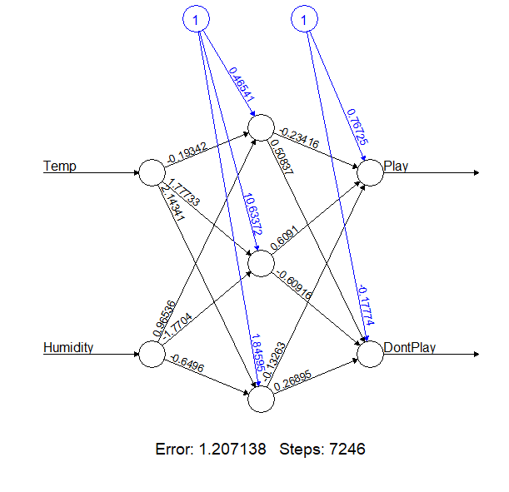

> gwplot(network_prak7,selected.covariate="Temp")

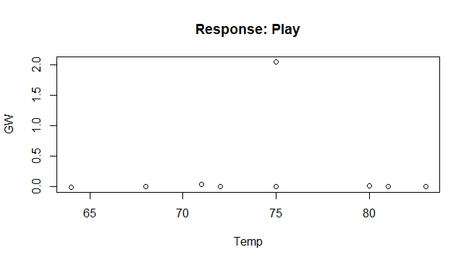

> gwplot(network_prak7,selected.covariate="Humidity")

